GovHack 2019

NICI Architecture



Document Information

|  |  |
| --- | --- |
| Document Owner | GovHack 2019 |
| Title | NICI |
| Description | NICI Architecture |

Table of Contents

1. NICI Architecture 4

1.1 Overview 4

1.1.1 High level architecture 4

1.1.2 AI Platform 4

# NICI Architecture

## Overview

NICI is the National Investment and Commerce Initiative, the modern gateway to connect investors, migrants and tourists to opportunities and services provided by federal, state and local government. NICI is an AI platform hosted in the AWS ecosystem, it comprises of an application endpoint that can handle a variety of communication channels including text through chat windows and also voice. The conversation then passes through to AWS Lex chatbot which is used to obtain more relevant information about the subject and whether they’re looking to invest, looking for work or are interested in tourism in certain areas. The chat bot is hooked up to speech services such as AWS Translate and AWS Polly so it isn't limited to just English speaking backgrounds. After NICI has obtained enough information about the subject and they ask for a recommendation the data is passed through the AWS Sage Maker to be passed through Machine Learning.

### High level architecture

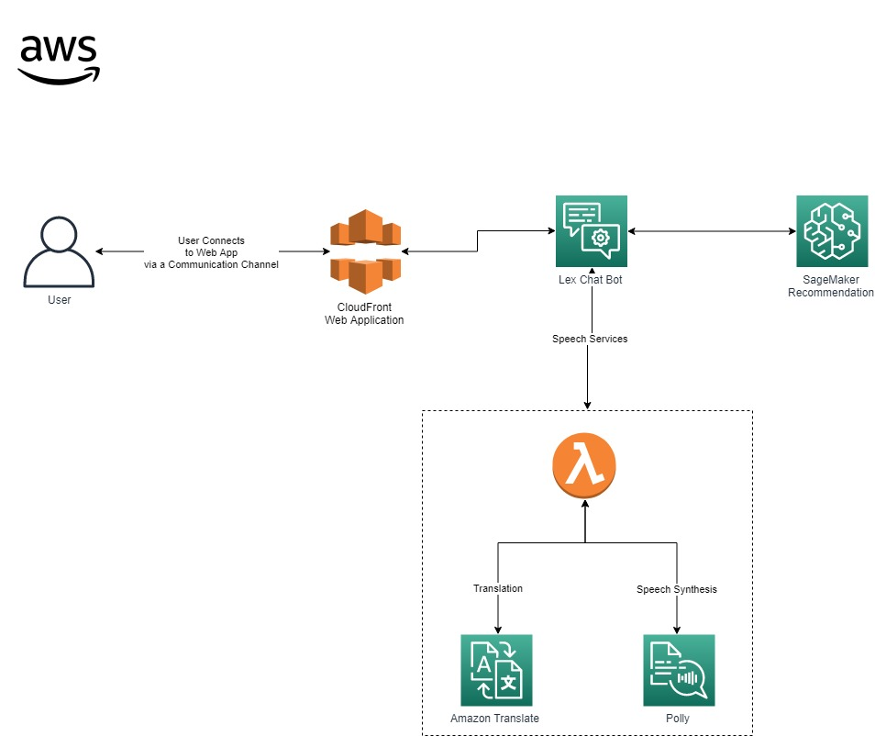

### AI Platform

* CloudFront Web Application
  + This is the communication endpoint for the user. This encompasses all the application artifacts including UI interface, communication with the backend API’s, databases for storage and AI components
* Lex Chat Bot
  + This service provides a conversational interface into the application using voice and text through Natural Language Processing (NLU) and Automatic Speech Recognition (ASR). This is the central point to the application which can call a host of other functions / API’s to enhance user experience
* Speech Services
  + AWS Translation Services allows the user to communicate to our AI platform in a variety of languages, asking questions and it being understood by our Chat Bot engine and AI. Responses and information can then be translated back to the user in the native language.
  + AWS Polly can turn text into lifelike speech. This is used to communicate verbally to the user if that is their chosen communication channel.
* Sage Maker
  + Sage Maker is the Machine Learning product that hosts the NICI Recommendation Engine. The recommendation engine makes recommendations based on datasets previously acquired as well as the dialog acquired through the users interaction with the chat bot.
  + The ML is built to give the best recommended action to prospective opportunity seekers, where “best” can change based on the requirements of NICI’s owner.
  + Data acquisition is handled in the ML side of the application
  + This is detailed more under the Machine Learning documentation.

